General explanation of the display content command

The display content command is for all alphanumeric displays attached on the ConFLiCT.
It defines the content of the display. Every value equates a character on the display. So the display content is completely user specific.

The display is organized in rows, columns, and screens.
For example the EA DOGM163 has 3 rows with 16 columns. So each screen has 3 x 16 = 48 characters. Because we can save up to 255 characters it is possible to specify 5 screens for this display (255 / 48 = 5.3125 → 5).
To continue with this example the value of display content 1 is the first character in the first row on the first screen. The value 16 is the last character in row 1 on the first screen. The value 48 is the last character on the third row on the first screen and value 49 is the first character on the first row of the second screen and so on.

You have to specify how long each screen should be shown with the display screens command.

There are two types of values. The static values show the same character all the time. This can be used for static text, names, units and so on. Possible values are in the table below. Normally typical ASCII values are accepted.

The dynamic values are placeholders for changing values (maybe a temperature or a RPM-value). They will be replaced by the ConFLiCT with the actual values. Because the values are longer than one character you need more than one character for a dynamic value.
A dynamic value starts with a special character, followed by the index and dummy to match the length of the replacing string.

Possible values of the display content command for the

EA DOGM163 display

table 1, dynamic values
name | start value  (in decimal) | index | length  (chars) | example value  (in decimal) | displayed  (example)
temperature | 192 | 1 - 24 | 4 | 192, 12, 0, 0 | 31,5
time | 193 | 1: hh; 2: mm; 3: ss | 2 | 193, 1 | 11
CPU clock | 194 | 1 | 4 | 194, 1, 0, 0 | 2400
usage | 195 | 1: CPU; 2: GPU; 3: RAM | 3 | 195, 3, 0 | 26
water flow | 196 | 1 | 3 | 196, 1, 0 | 120
RPM-value | 197 | 1 - 4 | 4 | 197, 3, 0, 0 | 1100
power | 198 | 1 - 4 | 3 | 198, 4, 0 | 80
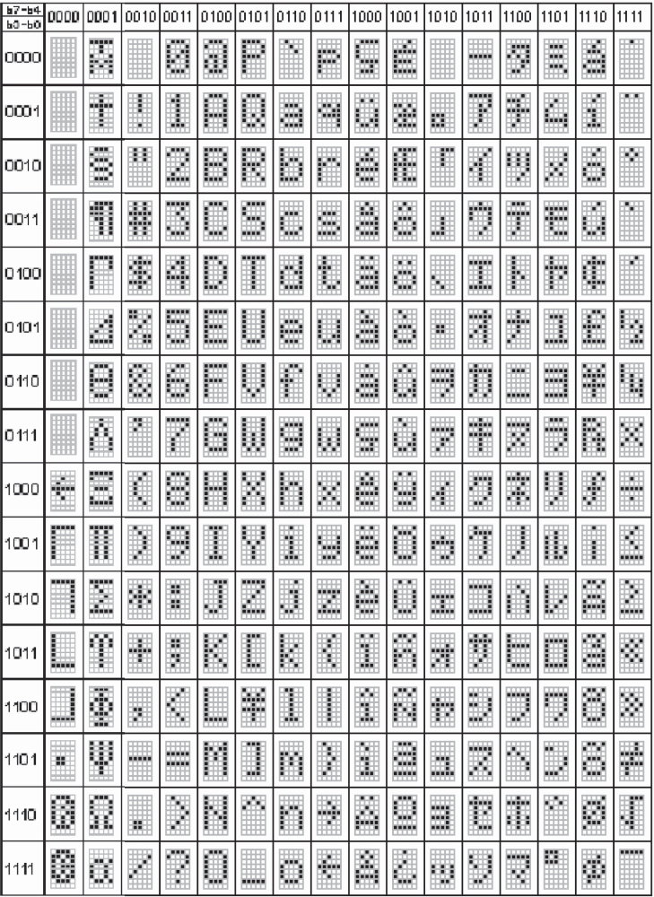
table 2, static values

source: EA DOG-M datasheet by electronic assembly GmbH

